**Bow-Tie Analysis of a Natural Gas Pipeline**

**Group Assignment**

The pipeline shown in Figure 1 below transports natural gas from GoPokes Refinery to Gas Distribution Company (GDC). Outside the boundaries of the enterprises, the pipeline is grounded and covers an industrial region, passing through a few residential areas. It has a length of approximately 2.25 miles, a nominal diameter of 16″, with an operating pressure of 369.8 psi. The pipe material is carbon steel and is constructed in accordance with the American Petroleum Institute (API) standard.

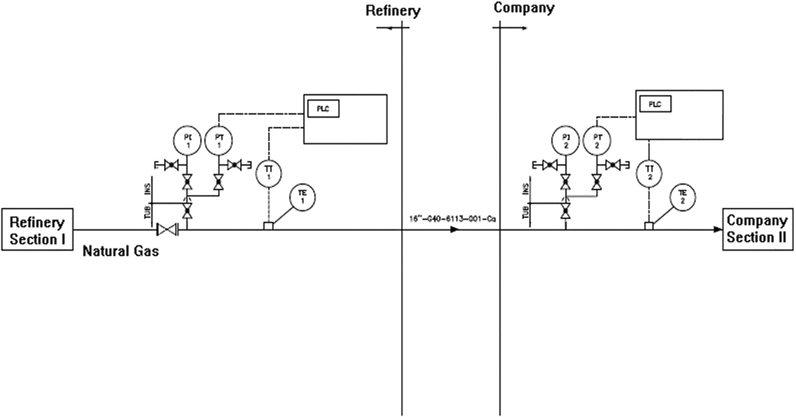

**1** Simplified Process Flow diagram of natural gas pipeline

The main dangers inherent in the natural gas flowing in the pipeline are associated with the high flammability of the methane, which could cause fires or explosions.

To avoid corrosion by the soil on the outer surface of the pipeline, an anticorrosive coating using triple-layer polypropylene was added. To protect the pipeline against electrochemical corrosion due to possible leakage currents present in the region, the pipeline has a cathodic protection system for all its buried sections.

The Control Center of the pipeline is located at the refinery. The control system has a local indicator and transmitter for pressure and temperature. Flow metering and shutdown valves are located inside the refinery. The control system is responsible for obtaining the information emitted by pressure and temperature transmitters and flow meters and for transmitting signals to the activators of the shutdown valves that have On–Off capability.

Instruments and cables are connected to a programmable logic controller (PLC), whose information is sent to a digitally distributed control system (DCS).

Operators are responsible for visual inspection of the condition of the valves in the field which includes checking whether valves are open or closed, using specific operational checklists and confirming that the observation data aligns with the control room analytics.

If pipeline pressure decreases enough to reach the low-pressure alarm set point, an alarm will sound in the refinery control room. The gas transfer operation can be remotely interrupted by activating the shutdown valves located inside the refinery proper. If the shutdown valves fail to close by remote activation, operators will be required to close the valves manually.

To prevent external interference, the pipeline route is signposted by signs and standardized landmarks, but these identifiers are only visible in the daytime.

Periodic preventive maintenance is performed to ensure reliability of the cathodic protection system, shutdown valves, pressure and temperature transmitters, flow meters, firefighting system equipment and pipeline signaling. However, the preventive maintenance plan is outdated.

The refinery has personnel assigned to daily observation patrols along the pipeline to the Gas Distribution Company.

There is no direct communication between the patrol workforce and local emergency services. Patrollers would have to radio back to the control room to initiate the emergency response protocol.

Inspections are conducted through visual observation along the pipeline route, seeking anomalies. An annual inspection is performed to evaluate the state of the coating and external corrosion of the pipeline.

There is no direct communication between inspection staff and the control room. Inspectors generate and submit a report to the operations supervisor who then would initiate any needed maintenance work requests.

The refinery and the Gas Distribution Company have the same resources for emergency action registered on the Emergency Response Plan. The refinery is responsible for pipeline integrity and emergency response along the pipeline route, except for the section that is part of the Gas Distribution

Company, which is managed by GDC.

The Emergency Response Plan has specific procedures for each accidental event. These emergency control procedures establish a set of actions that include a Mutual Assistance Plan between companies in the industrial area and specific actions for natural gas release.

A PHL/PHA was performed and the main risks to the natural gas pipeline were identified that could lead to hazardous release. The PHL/PHA did not consider intentional human actions such as terrorism or vandalism, nor occupational hazards such as slips and falls. Main risks to the system included rupture due to internal or external corrosion, external interferences such as excavations or utility strikes, damage from a lightning or ground motion from natural disasters such as flooding, or major earthquake. An additional potential threat could be rupture due to overpressure by procedural errors such as improper closure of a valve.

The consequences of the risks identified have the potential to generate damage to people, assets, the environment, and loss of natural gas supply to customers.

**Lab Exercise – Bow Tie Analysis**

Develop a Bow Tie Diagram for the top event of a **large leak of the natural gas pipeline.**

The Bow Tie Analysis should include:

* Identification of the threats that could trigger the hazard leading to the top event;
* Identification of consequences of the top event.
* Identification of preventive barriers that prevent or decrease the frequency of a top event.
* identification of mitigation barriers that limit the consequent effects.
* Identification of degradation factors capable of increasing the likelihood of failure of preventive or mitigation barriers.
* Identification and classification of existing safeguards blocking degradation factors, decreasing the likelihood of failure of a preventive or mitigation barrier.
* Identification of shortfalls or deficiencies in pipeline operation, maintenance, and management. Shortfalls may be related to threats, consequences, preventive or mitigation barriers, degradation factors or safeguards;
* Proposed recommended actions that could ensure maintenance of barrier integrity.

**Final Report Submission Requirements**

* Narrative introduction (Executive Summary) and description of system and potential threats.
* Bow Tie diagram – computer generated using images provided in Bow-Tie Analysis Images.ppt
* Table of Prevention Barriers, degradation factors, and degradation controls
* Table of Mitigation Barriers, degradation factors, and degradation controls
* Table of recommended corrective actions to mitigate or prevent threats and consequences
* Summary of Recommendations for Improvement and Conclusion
* Bibliography